Name:Ahmad mazen abd almonem awad

B.N:113

Topic:mobile computing

Screenshots:

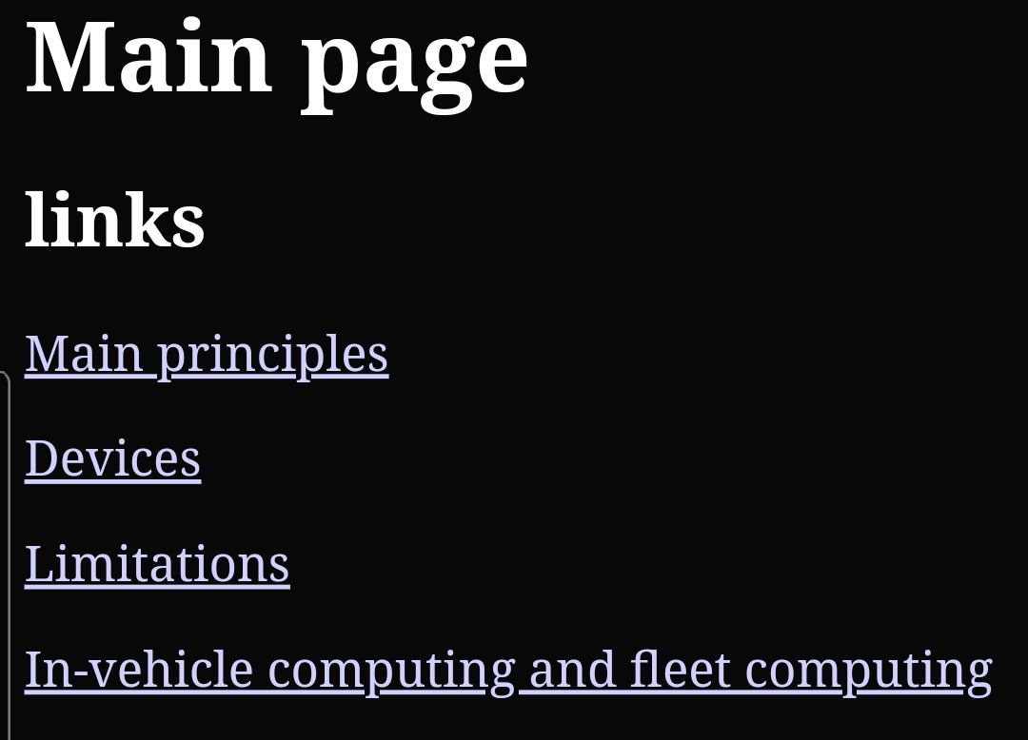

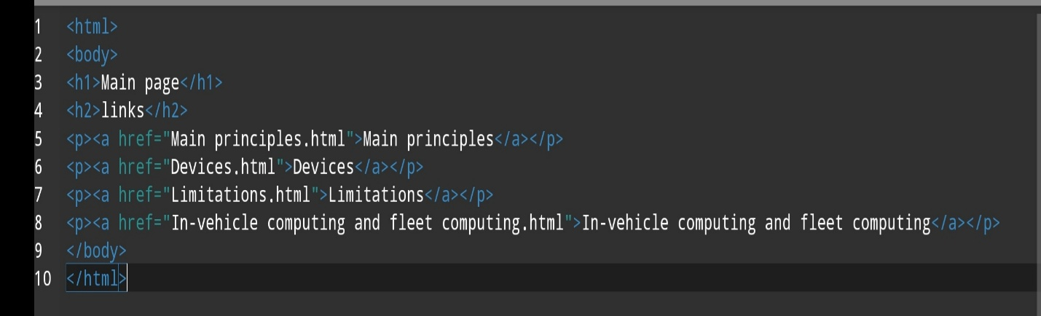Sourc code: